**A Quick Look into Some Suicide Statistics**

By: Chingyi Ie, Richard Yim

**Overview**

In order to figure out some trends in suicide rates, we looked at the “Suicide Rates Overview 1985 to 2016” dataset from Kaggle.com.

**Suicide Dataset Trends/Insights**

We first decided to take a quick look at the total suicide numbers for each year. However, since some countries have missing data for some years, it would be difficult and inaccurate to compare the world’s total suicide rate progression over the years, as the lack of data for some countries would result in a lower value for some years than we would expect. Hence, we decided to take a look at the suicide rates in the United States alone.

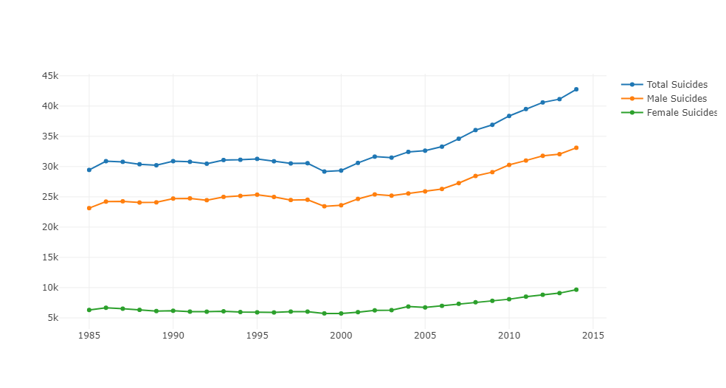

Fig 1: Total Suicide Numbers Over the Years in United States

As we see, total suicides in the United States seem to be relatively constant over the years 1985 to 2002, before a steady increase from 2003 to 2014. The figure above also shows a huge gap in suicide rates for male and females, as male suicides numbers seemed to be always higher than female suicide numbers.

This prompted us to further investigate the relation of sex and suicide rates. To do this, we decided to investigate by age groups. We first did an overall examination of total suicide numbers per age group.

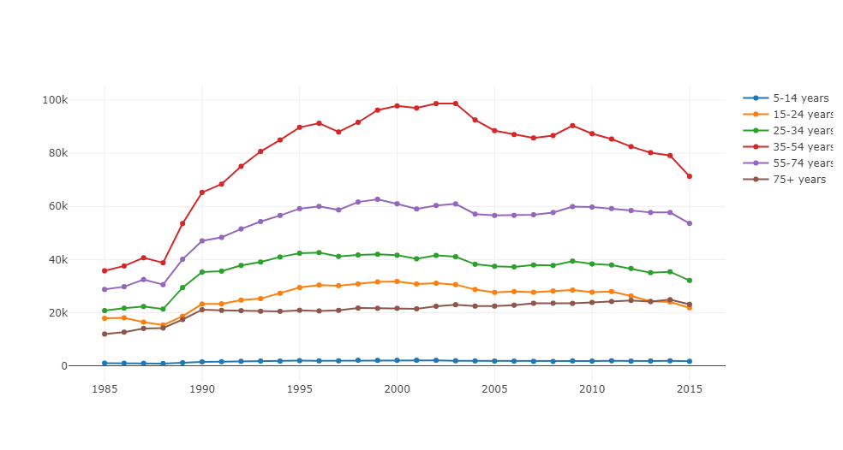

Figure 2: Total Suicides per Age group

Here, we are using the total data for the world, and while some countries contain missing data for the years, no missing data is found for the age groups nor sex, and hence will not make the comparison inaccurate. In Figure 2, we see that total suicide numbers are highest for ages 35-54, and lowest for ages 5-14.

We then did an examination of male and female suicide rates per age group. To focus purely on the rate of suicide and not the overall numbers, we decided to normalize the data to between 0 and 1, in order to better see trends in suicide rates.

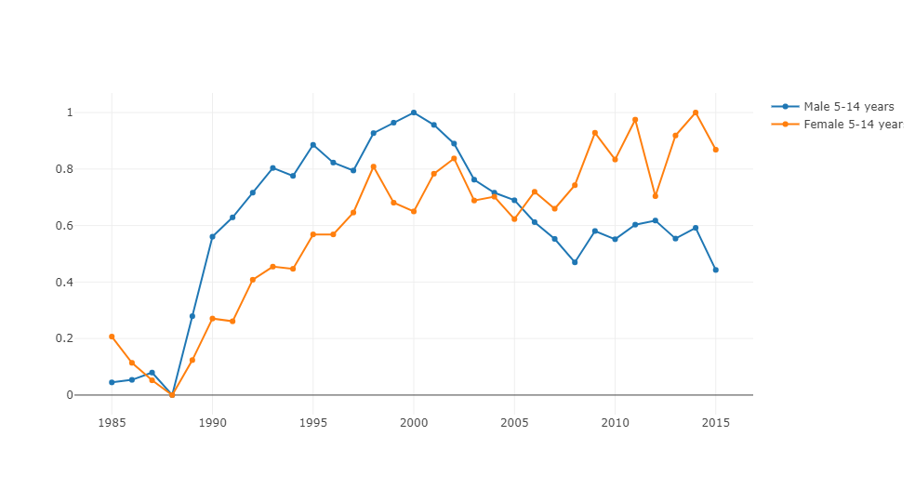

Figure 3: Male vs Female Suicide Rates for ages 5-14 years

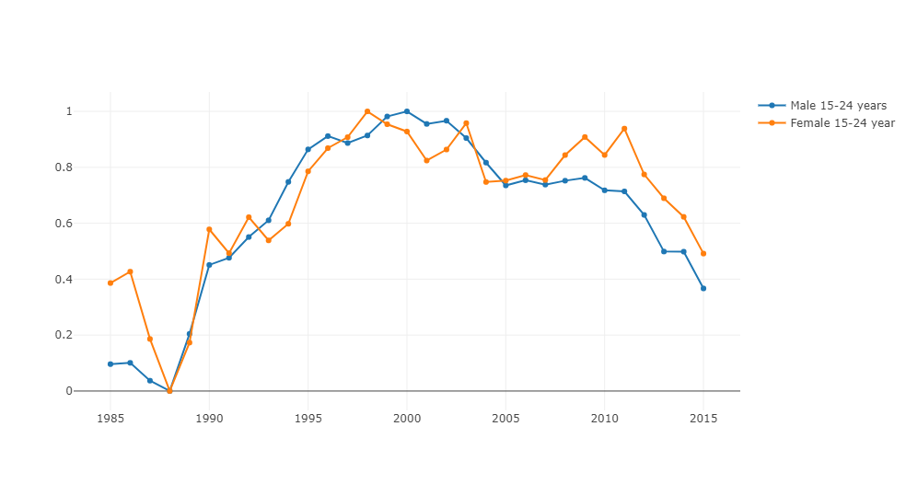

Figure 4: Male vs Female Suicide Rates for ages 15-24 years

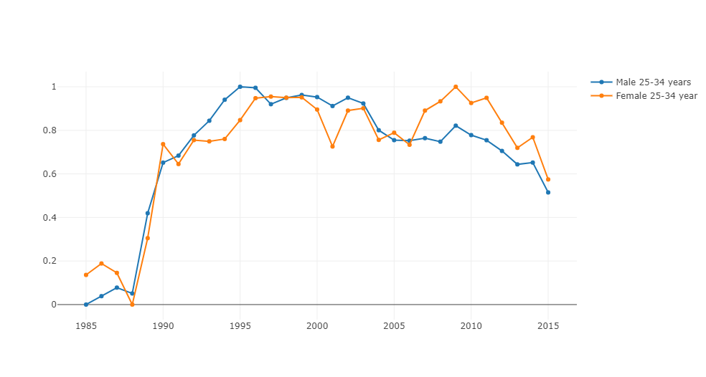

Figure 5: Male vs Female Suicide Rates for ages 25-34 years

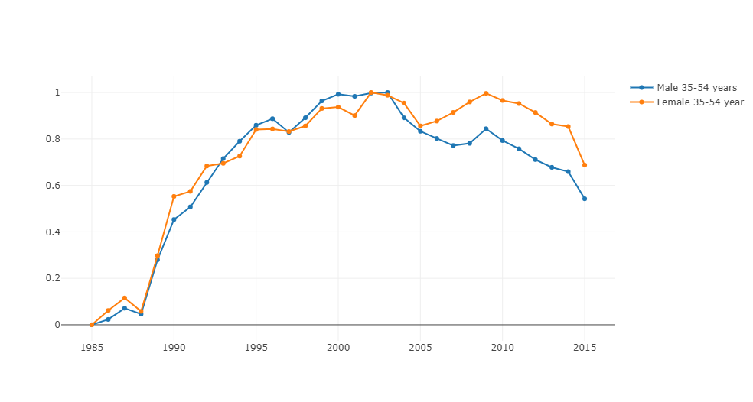

Figure 6: Male vs Female Suicide Rates for ages 35-54 years

Through this investigation we found an interesting yet disturbing trend, which is that in recent years, the change in the rate of suicide for females is actually higher than that of males for people below the age of 55 years! A look at figures 3,4,5,6 will show that the change in female suicide rates have surpassed that of males starting from around 2003 to 2008.

A quick look at the data for United States also show a similar rising trend for female suicides, especially in females from ages 5 to 34. Females of those ages show an increasing suicide rate which became the same or even higher than that of males, even though their rates used to be far below that of males. We see an example of this in figure 7 below.

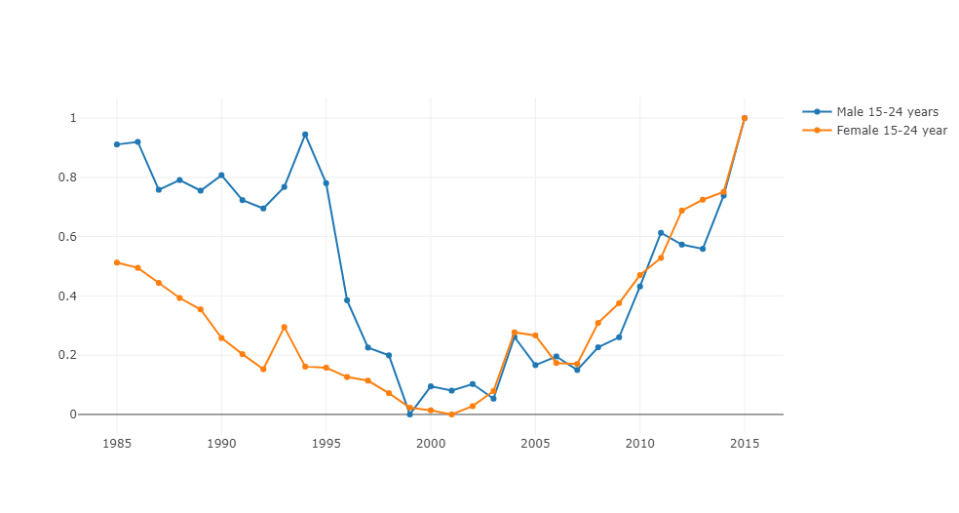

Another interesting trend we found is that females in the United States above the age of 75 have way higher suicide rates than males until very recently.

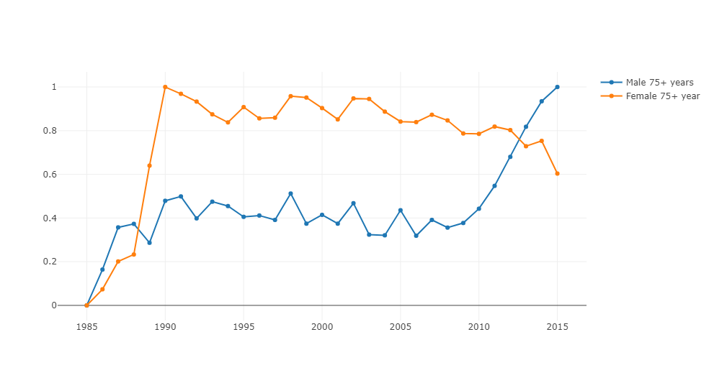

Figure 8: Male vs Female Suicide Rates in the US for ages 35-54 years

From figure 8, we see that the first jump in suicide rates occurred around 1990, and the huge gap in suicide rates continued all the way until 2013. Hence we see that although overall males have higher suicide numbers than females, when looking at the change in rates itself, females are actually increasing at a higher rate than men, which means that increase in the number of females that commit suicide are actually much higher than that of men.

In order to further research this disturbing trend, we looked at some studies that analysed the suicide rates of men as compared to women.

**Other factors that shows a trend with suicide**

**Conclusion**